5 steps to conducting a Startup Competitor Analysis (+Templates)

Posted by ANI MITEVA on JUNE 9, 2018
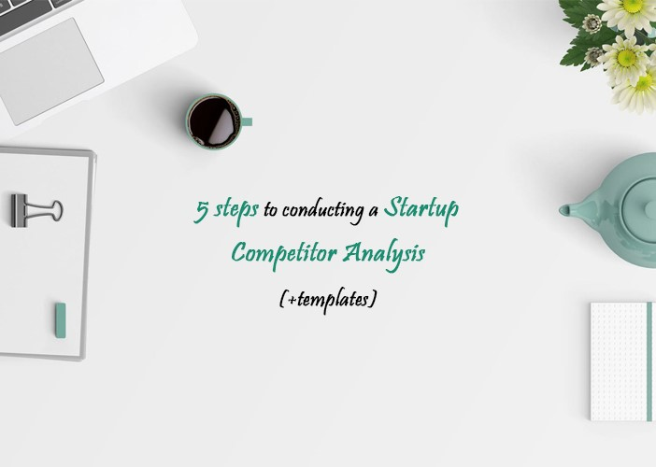
You think you know your competitors? Think again! In today’s article, I will test your ability to understand your strategic opponents – and show you how to perform a successful Startup competitor analysis so you can always be one step ahead.

During my experience as a Marketing professional, I have come to observe that a surprising number of companies underestimate the power of keeping an eye on the competition. In fact, I’ve had a Marketing director tell me that there is no need to track the performance of competitors because things are changing so quickly.


And you know, he is right – they do change from one day to another – but the moment you lose track of the companies that fight for the same piece of the cake as you, you get into a really risky position of getting delusional and unrealistic with your achievements and weaknesses.
For this reason, I will share with you how to perform a Startup competitor analysis from 3 different perspectives: Marketing, Product, and Pricing. And because I don’t like generic advice, we will spice things up with my personal examples, and I will provide you with some simple, but effective templates that I like to make when I study the competition. Let’s go!

Step 1: Identify your competitors

First things first, you can’t really analyze your competitors if you haven’t identified who they are and where do they live on the Internet.

Let’s say that you are a startup that is working its way towards becoming a mobile bank. At this point of your development, you really want to know your competition to see what is your relative position on the market – and of course, to find a competitive advantage that will help you stand out.

Because your core business is identified by the keyword “mobile bank” (or another one, of course, this is just an example), let’s go ahead and type this keyword in Google.
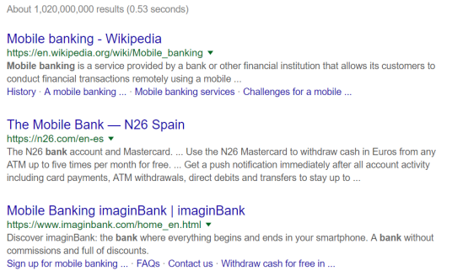

There are my results for the keyword “mobile bank” – and, as you can see, I already have my first two competitors. But it gets a little bit more complicated than that:
- When selecting your competitors, always take into account the country and the language you are typing in. Of course, if you are a business that sells digital products or servces, your main competitors can easily be from other countries that you are not operating in, so don’t necessarily exclude them – because they still might grab a piece of your market.

- First, select the keyword or keywords that describes your company the best – this will help you identify your direct competitors. Then, type this keyword in Google, and write down all companies that appear on the first few pages (as many as you consider relevant to your sector and business core).

- To refine your search and make sure that you are not missing out on any competitors, use tools like KWFinder and AnswerThePublic to discover as many keywords as possible that get close to the main core of your business. Repeat the search and write down all companies that appear between the first results of the search engine. For example, in the case of the mobile bank, possible keywords that could reveal additional indirect competitors might be “digital banking” or “online bank”.


Now that you have a list of companies that are positioning on Google for the keywords that you want to be positioning for, you are ready to start analyzing them. At this point, you can either investigate all of them at the same time, or visit their websites and exclude the ones that don’t seem to be an important/direct competition – it is up to you!

Step 2: Analyzing competitors from a Product perspective
At this stage of our Startup competitor analysis, we will take a profound look at how companies can take advantage of understanding their competition’s features, products and functionalities.
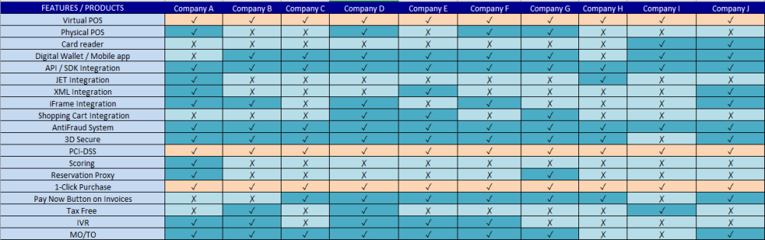

To explain it better, I did an example for a company that provides digital payment services to other businesses. Here is how I did it:
- On the first line of the Excel file, I put the names of the companies that I will be analyzing.
- Now, for the left-hand column, I visited the website of each competitor, and wrote down their main features, functionalities and products. Every time I visited a new website, I added more rows so I could have them all at a simple glance.
- Now comes the fun part – go ahead and add a √ symbol each time a company has the mentioned feature, and the Χ symbol if the company doesn’t have the mentioned feature.

To avoid visiting each website two times, I like to start with the first company, add all its products and features, add the √ symbol to each one of them (because I took them all from the first company’s website), then I move on to the second one, repeat the process, and so on. As a result, I end up with a simple and visual overview on how each company is doing on the Product/Tech side.


As you can see, I mark a row in orange if all companies happen to have the same exact feature or product, which helps me see that we shouldn’t rely on it if we want to obtain a competitive advantage. On the other hand, if I see that there is a feature that many companies have and we don’t, it’s usually a sign that we are missing out on something important.
And last but not least, if I see that there is a rare feature that only one company has out of all competitors, it could either be a sign of an important competitive advantage, or a feature that hasn’t proven its success yet. In either case, it is great to keep an eye on that.

I will leave a link to download the template in the end of the article, along with the others ones.

Step 3: Analyzing your competitors from a Marketing perspective
The next stage of our Startup competitor analysis is looking at it from a Marketing perspective with a couple of easy tables.

For this exercise, I’ve analyzed my competitors looking at their blog, social media, and frequency of publication, but you can go even further and investigate their SEO & SEM strategy.

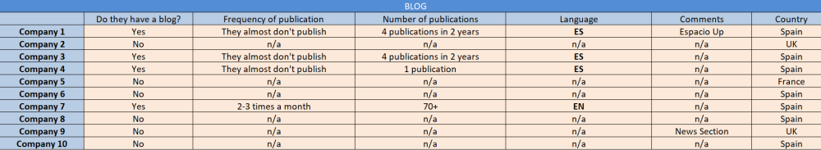

For a starter, I went ahead and visited the blogs of my companies. This is important for me because I want to know what efforts they are making to position themselves on search engines, and thus get more visibility in comparison to other companies. In my case (this table has real results, I just removed the names of the companies), I was delighted to see that my competition isn’t doing much of SEO, except for Company 7.

I will not enter into much detail with this table, it is quite simple and self-explanatory, but it gives you a nice overview of your digital competitive environment in terms of organic positioning. You can add or remove as many columns as you consider relevant to your sector and business activity.

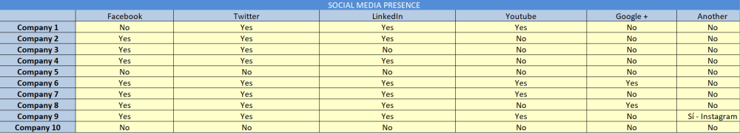

The next table is the social media presence of my competitors. What channels are they using to gain visibility on the Internet? Are there channels that you should be doing as well, but you aren’t? What efforts would that imply to you as a small/medium startup company, and is it going to be worth the investment in time?

When researching my competitor’s social channels, I also like to pay attention to the engagement of their followers with their company to get a hint on their performance.
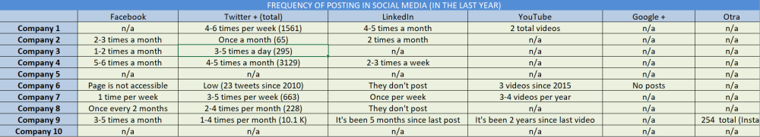
Another aspect of your competitor’s social media presence is their frequency of publication. Are they actively trying to build an audience and engage with their followers by publishing frequently, or they are rather irregular? Which are their most active social channels?
As you can see from my example, almost all companies have some social presence, but their behavior differ from quite frequent to very irregular. In any case, it is always a great idea to keep an eye on your competitors in every aspect of their digital presence, and it doesn’t really take that much time as you would normally expect to.

Step 4: Analyzing your competitors from Pricing perspective
And last but not least, one of the most important aspects when it comes to Startup competitor analysis, and any competitor analysis in general, is Pricing.

Of course, not all companies have their prices transparent and published on their website. In this case and when I consider that a competitor is highly relevant, I contact them presenting myself as a potential customer interested in their product or service. Just a little tip: if it’s possible, do not contact companies from a gmail account, especially if you are in the B2B sector – it doesn’t seem very legitimate, and you might not receive a response at all. Whenever possible, try to reach them out using a professional email – even if that means asking a friend to do that for you as a favor.



Now, to the pricing. In the startup world and especially in SaaS companies, pricing is usually based on a Subscription model or/and a Pay-per-Use model. In our case, we will focus on Subscription models so you can get a general perspective on how to build your Excel.

Let’s imagine that you are a company that sells communication services, such as phone support software and apps for call centers. Your Pricing sheet might look something like this:
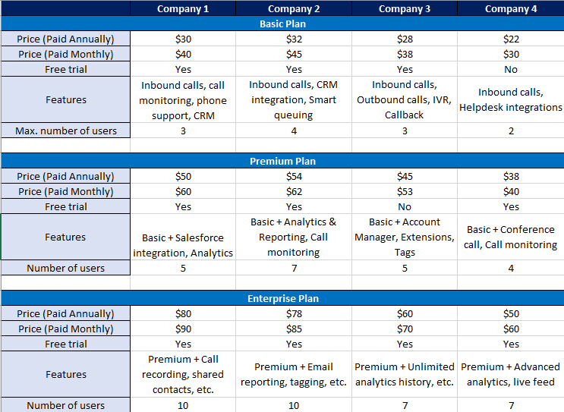

In Subscription models, many companies will make you a discount if you are paying annually, which is a great strategy to ensure that you will stay as a long-term client. For this reason, it is important to specify if prices vary depending on whether you will be paying monthly or annually.

Additionally, I’ve added other things relevant to the price that will help us understand the pricing differences from company to company. Information like the features that come with each plan, the minimum/maximum number of users, and whether there is a free trial or not are a great way to put yourself in the mind of the customer and try to make an informed decision from his perspective.


We all know that price is not the only element to consider when making a decision. Which competitor gives the better product in relationship with the price? Who provides the highest value? Is there a free trial to reduce pressure and give the customer a taste of the service? You need to be asking yourself these questions to better understand your current position on the market.

Step 5: Conclusions from your Startup competitor analysis
Now that you’ve conducted your investigation, it is time to make the final conclusions and see where you are at the exact current moment. Maybe you will find out that you are doing better than what you expected. Maybe you will find out that you are falling behind your competition in many (or in the most important) aspects.

No matter what you discovered, be honest with yourself. Are you growing at the same pace as your competitors? What are your strengths and weaknesses? Where is it that you want to be? Take your time to make the right conclusions, and work smarter to become better every day.

And, as promised, here are the free templates that you can download. If you are having troubles with the link or have any questions, send me an email at animitevabg@gmail.com

I hope you liked the article! Stay tuned for more!

Aus <https://mktoolboxsuite.com/2018/06/09/5-steps-to-conducting-a-startup-competitor-analysis-templates/>

